**WalkEZ**

**Project Documentation**

University of Calgary, ILS 2019

Maaz Khurram

Kevin Zhang

Contents

1. Introduction 3

1.1. Usage: 3

1.2. Project Objectives & Constraints 3

1.4. The Persona 3

1.3. The WalkEZ 4

2. Technical Documentation 5

2.1. Schematic 5

2.2. Major Circuits & Components 5

2.2.1. HC-SR04 Ultrasonic Sensor 5

2.2.2. PIC16LF1778 Microcontroller 7

2.2.3. 9V to 5V Voltage Regulator 8

2.2.4. Pulse/Search Input 9

2.2.5. Voltage Amplifier 10

2.3. Software Development 11

2.3.1. Interfacing PIC with HC-SR04 Ultrasonic Sensor 11

2.3.2. Processing and Outputting Audio 15

3. Project Management 18

3.1. Scrum 18

3.2. Teamwork 20

4. References 21

# 1. Introduction

## 1.1. Usage:

The WalkEZ project is the design project of Group 3 of the 2019 Integrated Learning Stream (ILS) program for second year electrical engineering students at the University of Calgary. Group 3 consist of two members, Kevin (Zelong) Zhang and Maaz Khurram. This documentation is primarily split into three sections. The first section will introduce the WalkEZ project and discuss its impact, feasibility, and limits. The second section will outline the technical details associated with the implementation and production of the WalkEZ. Finally, the third section will examine the project management and teamwork techniques used in the WalkEZ project.

## 1.2. Project Objectives & Constraints

The ILS design project is meant as an integration of all second year winter courses. The main design is that of an audio player to be used by a specific user. The term is divided into two parts, with the students learning how to build specific components of the audio player from technical courses in the first portion and then designing and implementing their designs in the latter portion.

In addition, the design must meet several design constrains as follow:

* Design must include the PIC16LF1778 microprocessor
* Design must produce sound waves audible to humans
* The primary functionality must be auditory
* Design must include user interaction
* Total cost for development must not exceed $60
* Design must be ready for demonstration by April 18, 2019

## 1.4. The Persona

As mentioned in the previous section, the WalkEZ is intended to be used by the visually impaired. In the process of developing the idea of the WalkEZ, a persona was built to better understand and emphasize with the user. For the WalkEZ project, the ideal beneficiary is Tom. Tom is an elderly man in his 60’s who suffers from cataracts. His condition has recently gotten so bad that he can no longer see clearly in any direction over 1 meter and his eyes have become highly sensitive to light. As a result, he can no longer navigate in public and has lost his mobility. Tom’s doctor recommends that he start learning the white cane so he can avoid slipping or tripping over obstacles. Tom wants to maintain his independence and not have to rely on his friends or family to help him all the time. At the same time, he also feels anxious and uneasy about traversing unfamiliar settings and is worried about having an accident. So Tom decides to attend a white cane training course and instead of the traditional white cane, he is offered to try the new WalkEZ cane.

The persona is built such that it most represent the customer base. Two of the biggest causes for blindness according to CNIB are cataracts and age related muscular degeneration. According to the National Eye Institute, the onset of cataracts is significantly higher in older people. In addition, the World Health Organization published in 2018 that people with visual impairment are predominantly over the age of 50. With these facts, it made the most sense for Tom to be an elderly person.

## 1.3. The WalkEZ

According to Canadian National Institute for the Blind, about 1 in every 70 Canadians are blind or partially sighted with an additional 1 in 6 Canadians suffering from eye diseases which may lead to sight loss. One of the greatest challenges to people with visual impairment is the loss of mobility and navigation abilities. One of the tools to assist the visually impaired is the white cane. The white cane is a cane usually between 1.2 to 1.6 meter which is swung in a sweeping motion to detect obstacles and changes in elevation. However, learning to use the white cane may take anywhere from weeks to months to fully learn and master and many people ultimately lack the confidence to use it in a public setting.

The WalkEZ is designed to be an upgrade to the traditional white cane. The intention is to provide an audio feedback in addition to the haptic feedback provided by the white cane which in theory will allow for easier navigation and greater mobility. The WalkEZ is designed to give confidence to the visually impaired by allowing them to use the audio feedback to widen their range of detection.

At a basic level, the functionality of the WalkEZ is to convert distance into audio. An ultrasonic sensor (HC-SR04) is used along with the PIC to detect the distance. After detecting the distance, the PIC converts the distance to a frequency and outputs a sinusoidal wave of that frequency through its digital to analog converter (DAC). The signal from the DAC is amplified through an amplifier and then played by a piezoelectric buzzer. A small distance, or in other words, a very close object will be translated into a loud high pitched tone. In contrast, a large distance or a faraway object would be translated into a soft and low pitched tone. Two modes, pulse and search, are available for the user to choose. In the pulse mode, a single distance will be detected and a singular tone will be played. In the search mode, distance and audio are continuously detected and played. Physically, the WalkEZ will be very similar to the white cane except for the addition of circuitry inside the handle, a batter compartment, a pulse mode button attached to the tip of the cane, a search mode button on the side of the handle, a volume control knob on the handle, and an ultrasonic sensor attached near the bottom part of the tip section. Due to the nature of the project, several more design constrains are placed. The additional constraints are:

* All circuitry must fit internally inside the handle of the cane
* Only external components are pulse/search buttons and ultrasonic transmitter/receiver
* Product must operate on battery power alone
* Product must detect obstacles and distances up to 1 meter
* Product must be able to produce frequencies from 500Hz to 5000 Hz

Due to these additional constraints, it was decided that the SD card would not be used to save space as the WalkEZ does not require very complex audio outputs. Instead, the tone is generated on the PIC which eliminated the need to include the bulky SD card breakout board in the design. Another concession was the decision to not use a filter. This decision is also a consequence of the space restriction as it is not possible to fit two batteries in the handle chassis. As a result, it is not feasible to use a high pass filter as that would cancel the offset and thus would need negative voltage to be outputted through a speaker. Without the space to accommodate multiple batteries, it was decided that filtering was not going to be a part of the WalkEZ audio output.

# 2. Technical Documentation

In this section, the technical aspects of the design will be discussed in detail. Some schematics and diagrams are referenced from datasheets of the components. All datasheets used are listed in the reference section. Electronic copies of the original designs as well as the source code are public on GitHub at <https://github.com/MaazKhurram/WalkEZ>.

## 2.1. Schematic

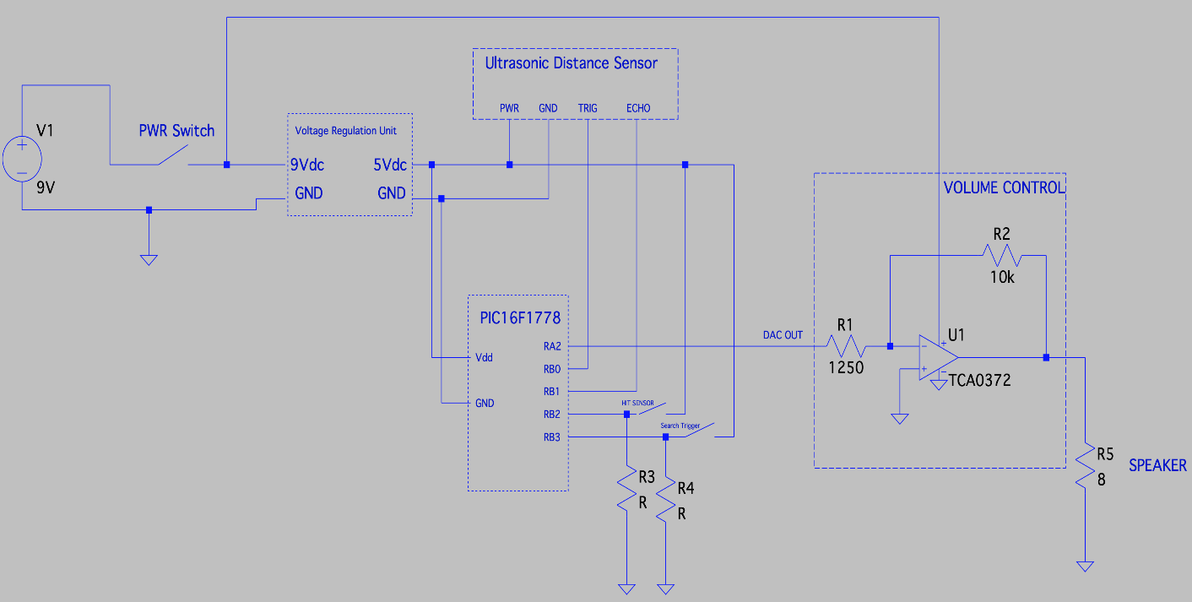

Figure 1. Schematic Diagram of the WalkEZ

## 2.2. Major Circuits & Components

### 2.2.1. HC-SR04 Ultrasonic Sensor

The Longruner HC-SR04 is the ultrasonic sensor used in the WalkEZ to detect distance. The sensor is able to detect from 2cm – 400cm with a maximum accuracy of 3cm. The sensor has 4 pins, VCC, GND, TRIG and ECHO. The safe operation parameters are as listed below in Table 1.

Normal operation of the HC-SR04 starts with sending a logic high pulse to the TRIG pin with the minimum width of the pulse being 10 microseconds. After sending the TRIG pulse, the ultrasonic transmitter will send 8 pulses of 40 KHz waves. Upon receiving a 40 KHz response from its receiver, the sensor will generate a logic high pulse and output it through the ECHO pin. The timing of this device is shown in figure 2. The width of the pulse is distance dependent (long distance = wider pulse). The duration of the ECHO pulse can then be used to calculate the approximate distance using the formula:

$$Distance(m)≈\frac{ECHO duration\left(s\right)*343m/s}{2}$$

This formula assumes that the pulses sent out are travelling through air as the average speed of sound in air of 343m/s is used. It also assumes the ultrasonic waves travel in a straight line to the obstacle and is reflected straight back to the sensor hence the division by 2. This means any interference such as refraction, reflection off a uneven surface, or any absorption by specific materials will affect the performance and accuracy of this sensor. In addition, the receiver will generate an ECHO pulse whenever it receives a 40 KHz response which means it is possible a false reading may occur due to a non-related 40 KHz wave in air. However, this is fairly unlikely as 40 KHz is not a commonly used signal in communications or power. But this does mean using multiple HC-SR04 sensors in close proximity may cause errors in readings.

Initial testing of the HC-SR04 was done to determine its practical accuracy and range. Trials were conducted for different materials at various distances and compared to actual distances. The results of the tests can be seen in table 2. From the results, it would seem that the HC-SR04 performs the worst with cloth like fabrics with a maximum detection range of only 1 meter. Given this, it was decided that the maximum trustworthy distance detection should be set to 1 meter to avoid dubious results from material differences and other interferences.

|  |  |
| --- | --- |
| Maximum Working Voltage | 5 V |
| Maximum Working Current | 15 mA |
| Measuring Angle | 15o |
| Minimum Trigger Input | 10 µs |
| Dimensions | 45 x 20 x 15 mm |

Table 1. Safe Operation Parameters of Longruner HC-SR04 Ultrasonic Sensor

|  |  |  |  |
| --- | --- | --- | --- |
| Actual Distance(cm) | Distance from Drywall(cm) | Distance from Glass(cm) | Distance from Cloth Fabric(cm) |
| 2 | 2 | 2 | 2 |
| 5 | 5 | 5 | 5 |
| 10 | 10 | 10 | 10 |
| 20 | 20 | 20 | 20 |
| 40 | 39 | 40 | 39 |
| 60 | 60 | 61 | 63 |
| 80 | 81 | 79 | 77 |
| 100 | 100 | 102 | 96 |
| 150 | 146 | 155 | N/A |
| 200 | 205 | 203 | N/A |
| 250 | 241 | 246 | N/A |
| 300 | 307 | 303 | N/A |
| 350 | 344 | 354 | N/A |
| 400 | N/A | 389 | N/A |
| 450 | N/A | 439 | N/A |

Table 2. HC-SR04 Detection Ranges for Different Materials

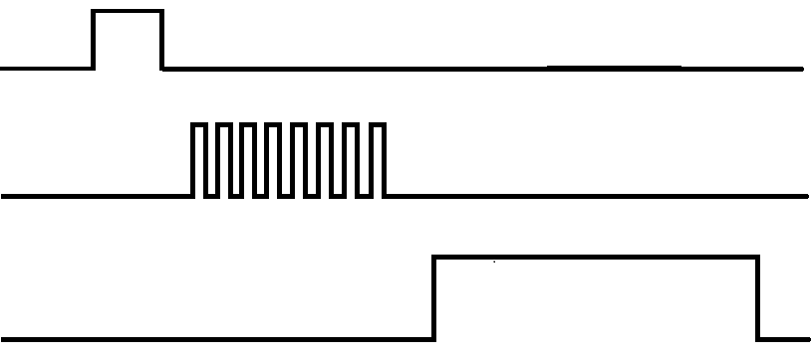

10 µs High Pulse

Distance Dependent High Pulse

8 High Pulse (40 KHz)

ECHO

Transmitter

TRIG

Figure 2. Longruner HC-SR04 Timing Diagram

### 2.2.2. PIC16LF1778 Microcontroller

The PIC16LF1778 is an 8-bit flash microcontroller with 28 KB of flash memory and 2 KB of data RAM. The architecture of the PIC is similar to that of a single core pipeline processor and instructions are ran sequentially. The PIC has several internal oscillators capable of providing different clock sources. The highest clock speed is 32 MHz and the lowest is 31 KHz.

The PIC contains several modules which are used in this project. The modules used are:

* Timer 1/3/5
* Timer 2/4/6/8
* 10 bit Digital to Analog Converter (DAC)

The functionality and usage of these modules will be discussed in section @@@@.

Four Input/Output pins, RB0, RB1, RB2, RB3, and RA2 are used in the WalkEZ project. In addition to these the VDD and VSS are also used to power and ground some other components. The pinout of the PIC16LF1778 can be seen in figure 3 on the next page taken from the Microchip datasheet. The safe operating voltage of the PIC is 2.3 V to 5.5 V.

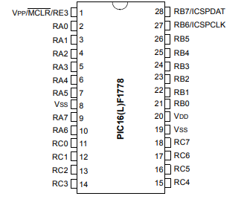Figure 3. Pinout of the PIC16LF1668 Microcontroller taken from Microchip Datasheet

### 2.2.3. 9V to 5V Voltage Regulator

In order to power the WalkEZ independent of a fixed power supply, a 9V battery was decided to be the source. Since the 9V battery is the only power source in the design, it is necessary to build a voltage regulator in order to allow for the safe operation of the PIC since its maximum operating voltage is 5.5V. In order to account for potential fluctuations and unexpected surges, it was decided that the regulator be a 9V to 5V regulator.

The regulation is achieved using a standard 7805 voltage regulator and two capacitors (1uF and 10uF). The input to the regulation unit is 9Vdc coming straight from a common 9V battery and the regulation unit makes sure that the output is set to 5Vdc regardless of any fluctuations or decrease in voltage level (as the battery becomes weaker with use) at the input terminal. The detailed schematic of the regulation unit is shown below as well as documented in the overall circuit schematic.

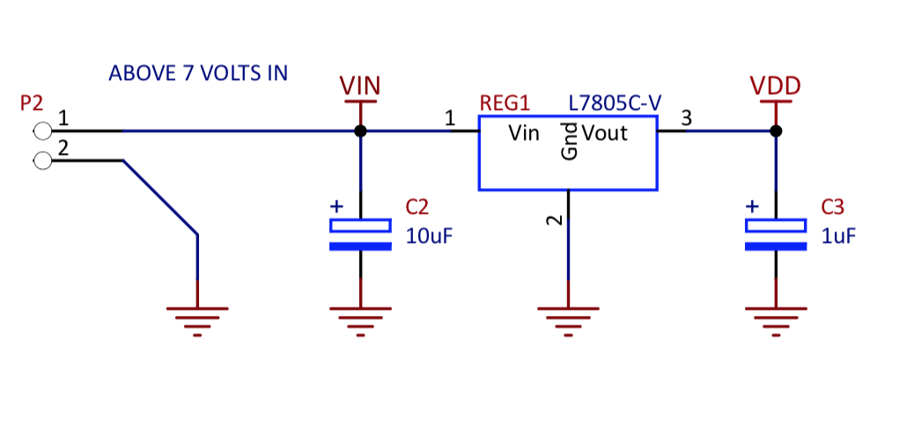

Figure 4. 9 to 5 V Voltage Regulator Diagram

### 2.2.4. Pulse/Search Input

In order to allow the user to choose between the pulse and search mode, two active high buttons are included in the WalkEZ cane.

The pulse button is located on the bottom of the tip of the cane such that tapping it on the ground would activate the button and cause the cane to enter pulse mode. Once the button is pushed, a single pulse is sent to the ultrasonic sensor and a single distance is detected, processed and outputted as a single tone lasting 1 second. Holding the pulse button will not produce any additional results. Only after the pulse button is released and then pushed again will the WalkEZ produce another tone.

The search button is located on the side of the handle near where the user would place their thumb. The search button when held down will enter the cane into search mode. While in search mode, WalkEZ will continuously search and output audio and will react to obstacles directly in front of the cane in real time. The search button has precedence over the pulse button which means when both are held down or pushed at the same time, the search mode will engage instead of the pulse mode. The input for the pulse and search buttons are transmitted to the PIC via the I/O ports RB2 and RB3 respectively. These buttons are also tied to ground with 910 KΩ resistors to ensure a stable logic 0 is read when inactive. Large resistors were chosen to reduce power drain when buttons are active. Figure 5 shows the circuit diagram of the button setup.

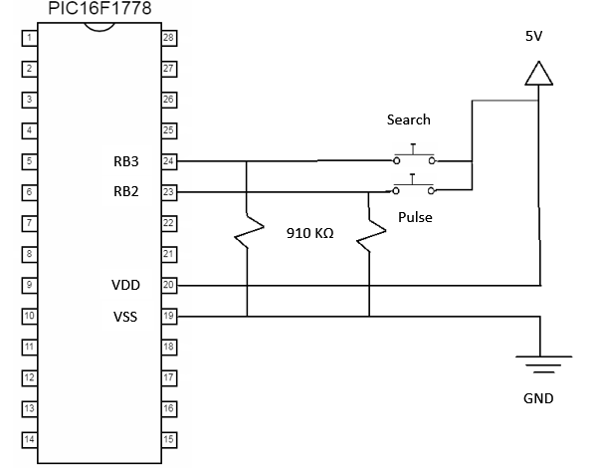

Figure 5. Pulse/Search Button Configuration Circuit Diagram

### 2.2.5. Voltage Amplifier

The output from the DAC module of the PIC for the WalkEZ was determined experimentally to be a sinusoid with a maximum amplitude of 1.05 V and a minimum amplitude of 0 V. The frequency of the signal varies between 500 Hz to 5000 Hz with 500 Hz representing the maximum allowable detection range of the sensor and 5000 Hz representing the minimum allowable detection range of the sensor. However, humans do not perceive all frequencies equally. According to Wikipedia, perceived human hearing can be represented by figure ##. Since the WalkEZ’s persona is the elderly, the frequency must not be too high or too low as the elderly are more prone to hearing loss in these ranges. The 500Hz to 5000Hz range is relatively stable to the human ear as compared to other ranges and thus was chosen. However, a difference of almost 10 dB is still present in the range. As the perceived hearing curve is irregular (not linear, logarithmic, etc.), the simplest solution is to enable the user to amplify the signal so they can find a volume that is acceptable to them. Since the battery is 9V, the amplifier is designed such that a 9 V output would be produced at maximum gain and an unchanged signal produced at minimum gain.

The amplifier is made from a power operation amplifier (TCA0372), a 0-10KΩ variable resistor, a 1.2kΩ resistor, and a 50Ω resistor. The op amp was chosen due to its high voltage and current capabilities. The TCA0372 can safely operate at voltages under 40 V and can output up to 1 A of DC current. The variable resistor is used in order to allow for the user to control the gain of the amplifier. The design of the amplifier is that of a non-inverting amplifier and the circuit diagram can be observed in figure 6. The gain of the amplifier is calculated using the following formula:

$$G=1+\frac{R_{var}}{R_{fixed}}$$

where G is the linear gain, $R_{var}$ is the resistance of the variable resistor in ohms, and $R_{fixed}$ is the sum of the two fixed resistors in series in ohms.

Using this equation, the range of voltages outputted by the amplifier can be calculated using:

$$V_{o}=G*V_{DAC}$$

where $V_{o}$ is the voltage out of the amplifier, G is the linear gain, and $V_{DAC}$ is the voltage coming from the DAC output pin of the PIC.

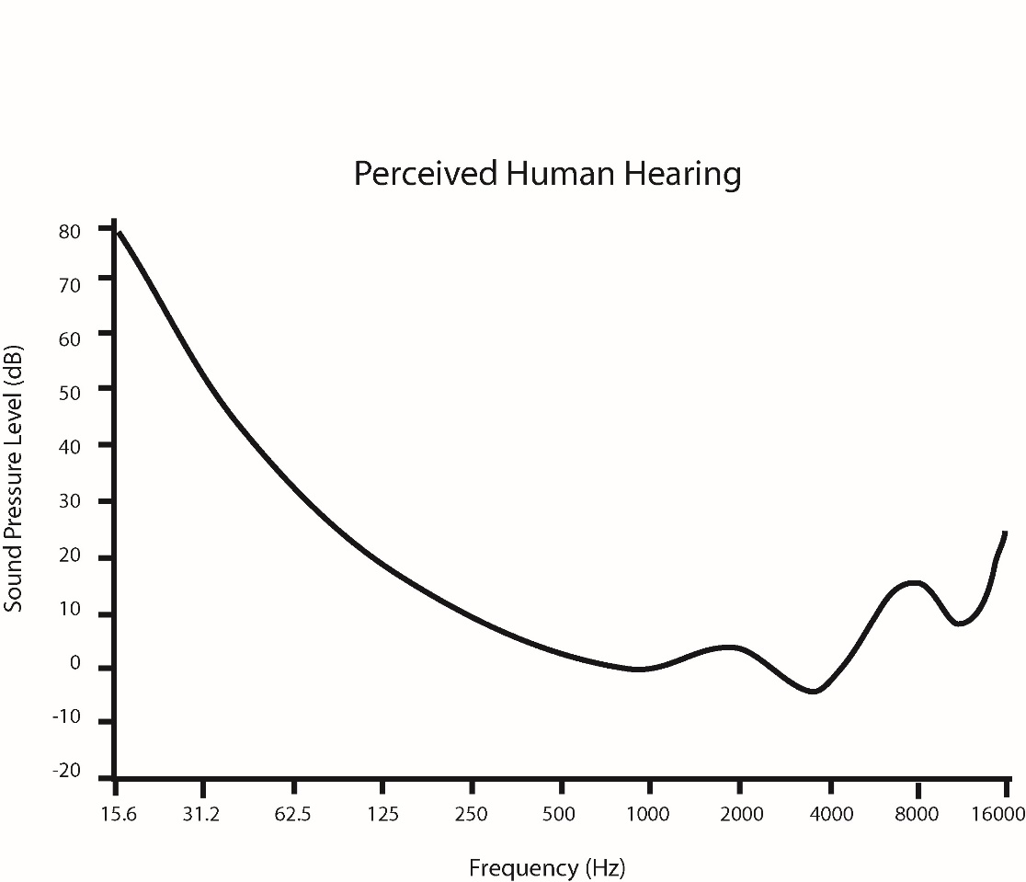Given that the output from the DAC is from 0 to 1.05V, and $R_{fixed}$ is 1250 Ω, it is calculated that the output voltage range of the amplifier is:

$$V_{o,min}=0 V$$

$$V_{o,max}=8.4 V$$

Figure 6. Perceived Human Hearing of Various Frequencies in Decibels (Source: Wikipedia)

## 2.3. Software Development

All software development for the WalkEZ project was completed for the PIC16LF1778 microcontroller. The source code is in C and compiled using the XC8 compiler. The environment used to develop is MPLABX and the MPLAB PIC kit 4 is used as the debugger/compiler hardware. The main goal of development is split into two distinct parts. The first is to allow the PIC to successfully interface with the HC-SR04 ultrasonic sensor. The second is to then convert the data from the HC-SR04 into an audio signal and output it as an analog signal.

### 2.3.1. Interfacing PIC with HC-SR04 Ultrasonic Sensor

In order to interface successfully with the ultrasonic sensor, the PIC must first generate a 10 µs logic high pulse and send it to the TRIG pin of the sensor. Then, the PIC needs to wait for the ECHO pin to change from 0 to 1 and then measure the width of the ECHO high pulse. To accomplish this, the Timer1/3/5 and Timer2/4/6/8 modules are used to time events and to measure duration of pulses.

Communication between PIC and Sensor:

In order to communicate with the sensor, the PIC must be able to write to the TRIG pin and read from the ECHO pin. It was decided in this project that the TRIG pin would be connected to the RB0 I/O pin and the ECHO pin would be connected to the RB1 I/O pin. In order for the PIC to read or write from an I/O port, it must first be set up. Two 8-bit registers control the B ports, TRISB and ANSELB. TRISB controls whether the I/O pins RB0-RB7 are input or outputs pins and ANSELB controls whether the I/O pins RB0-RB5 are read or written in digital or in analog. Both these registers are readable and writable so they can simply be set in the code.

Sending the Trigger Pulse:

The Timer2/4/6/8 module are four 8-bit timers which are configured in this project to be free running and only used with internal clocks. For the interfacing, Timer4 is used to send a pulse to the sensor. The function ConfigureTimer4 sets up Timer4 to send a 10 µs pulse. The way to calculate the ideal period of a timer is as follows:

$$T=\frac{pre-scaler*post-scaler*T4PR}{f_{clk}}$$

where T is the period in seconds, pre-scaler and post-scaler are defined in bits <6:4> and <3:0> of T4CON, $f_{clk}$ is the frequency of the source clock in Hz, and T4PR the value of the period register.

Using the values used in ConfigureTimer4 in Timer.c, the period is exactly 10 µs.

With the help of two macros, TIMER4_START() and TIMER4_WAIT(), it is possible to send a 10 µs pulse. In the source code, this is defined as the macro SEND_TRIGGER. The general idea is to set RB0 to 0, then to 1, then back to 0 again. The first set to 0 ensures a clean 0 to 1 transition and erases possible floating values lingering on the output pin. The set to 1 has to be controlled to be 10 µs and this is done by first calling TIMER4_START() which starts Timer4, and then calling TIMER4_WAIT() which idles until Timer4 is completed. Since Timer4 is configured to have a period of 10 µs, this means exactly 10 µs will elapse between the end TIMER4_START() and the end of TIMER4_WAIT(). Thus, by setting RB0 to 1 before calling these two macros then setting it back to 0 afterwards will ensure a high pulse of 10 µs will be sent to TRIG.

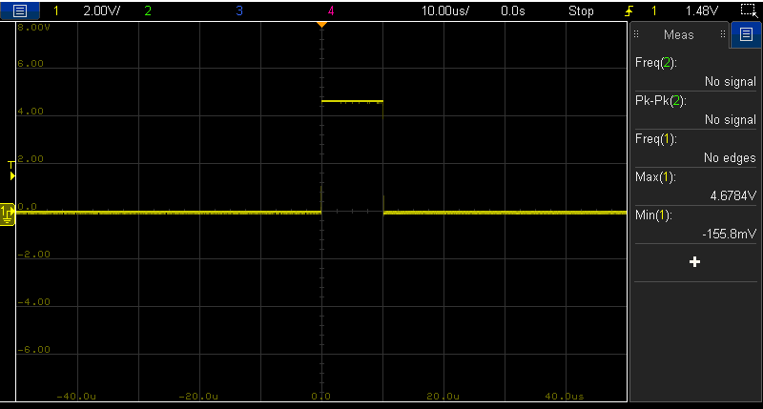Figure 7. Oscilloscope shot of the Trigger Pulse

Reading ECHO and Measuring Duration:

To measure the duration of the high pulse on ECHO, the program needs to first wait for a transition from 0 to 1. Once the input from the sensor makes this transition, Timer1 is used to measure the duration of the high pulse.

Timer1/3/5 are 16-bit timers with gate control options. These timers are similar to Timer2/4/6/8 except:

* Two holding registers TMR1H and TMR1L
* Only Prescaler of 1,2,4,8 can be used
* No postscaler
* No PR register, default rollover at 2^16
* Gate Control register
* Only FOSC, FOSC/4, or external clock source

The advantage of using Timer1/3/5 lies within its 16 bit precision. Having 16 bits to work with makes it so that Timer1/3/5 have a far wider range and accuracy than Timer2/4/6/8. For this project, precision is key as a measurement differences of 1 µs is equivalent to a 1cm error in distance.

The gate control functionality of Timer1 was not used in this project since Timer1 is used to measure a single pulse and not multiple pulses nor is it used to detect certain patterns. Since the HC-SR04 has a maximum accuracy of 3cm, and the detection range is between 0 – 100cm, Timer1 has to be able to accommodate any measurements in this range with at least this precision. Since Timer1 does not have a post-scaler, its period is defined as follows:

$$T={(2}^{16}-1)* \frac{pre-scaler}{f_{clk}}$$

where T is the period of Timer1 in seconds, 2^16 represents the default rollover limit, pre-scaler is defined as bits <5:4> of the T1CON register, and $f_{clk}$ is the frequency of the source clock in Hz.

The precision of Timer1 can be calculated as below:

$$Precision= \frac{T}{(2^{16}-1)}$$

where precision is the maximum error in time in seconds, which is also equal to the period of 1 single tick.

ConfigureTimer1 in Timer.c sets Timer1 such that a single tick takes 1 µs and the overall period of Timer1 is ${(2}^{16}-1)$ µs.

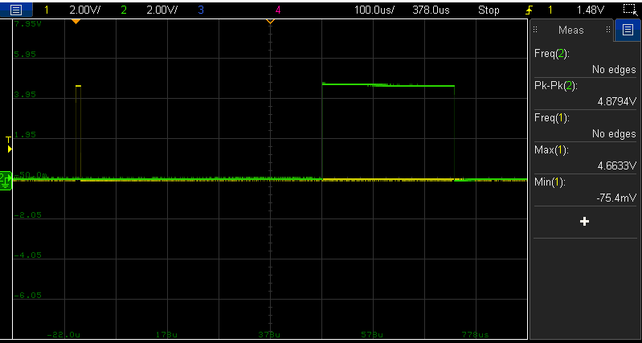Using Timer1 to measure the duration is similar to using Timer4. Once ECHO transitions from a 0 to a 1, Timer1 is started with TIMER1_START(). When ECHO transitions from a 1 to a 0, TMR1H and TMR1L are read, combined and saved as an unsigned long. This duration variable is the goal of the interfacing code and it can then be used to generate the audio signal in the next part. A single pulse and response can be seen in figure 8.

Figure 8. Oscilloscope shot of a Single Trigger Pulse and the Echo Response Pulse

### 2.3.2. Processing and Outputting Audio

After obtaining the duration of the high pulse on ECHO, it must be processed to translate this variable into a sinusoid and output it at a corresponding frequency. The modules needed to do this are the Timer2/4/6/8 and the Digital to Analog Converter1/2 (DAC) modules. The Timer2/4/6/8 has already been discussed in the previous section for its use in timing events. The DAC1/2 is a PIC module capable of converting a digital signal to an analog signal.

Digital to Analog Converter:

To use the DAC, it must first be set up. The register DAC1CON0 controls the configuration of the 10-bit DAC1 module. This register controls whether the DAC is on or off, which output the DAC writes to, and which reference to take as Vdd and Vss. DAC1 has two holding registers, DAC1REFH and DAC1REFL. These two make up the 10 bits necessary to output a 10-bit analog signal. Essentially, the DAC will read these two registers and output the pseudo-register value held in DAC1REF as a 10-bit number and the voltage outputted from its output will be:

$$V_{DAC1}=\left(Vdd-Vss\right)*\frac{DAC1REF}{2^{10}}$$

where $V_{DAC1}$ is the output voltage on the DAC output in volts, Vdd is source voltage, Vss is ground, and DAC1REF is the 10-bit number made from combining DAC1REFH and DAC1REFL.

Translating Duration to Audio:

In order to output a sinusoid, the DAC must receive writes to its reference registers. Since the SD card is not being used for this project, a sample list of a full cycle of a sine wave must be kept on the PIC itself. Then, these sample amplitudes can simply be written to the DAC reference registers and then outputted. The speed at which these samples are written to the DAC would determine the frequency of the sine output and this speed could be controlled using Timer2. Thus, it is necessary to convert duration, which is the number of ticks of Timer1 into a value for T2PR for Timer2. For the desired range of 0-100cm, the corresponding duration values were experimentally determined to be between 0 and around 6300. The full test results can be seen in table 3 In order to convert the duration values into actual distances, the equation from the HC-SR04 datasheet can be used.

To convert the duration of 0-6300 to a T2PR value of 0-255 requires division. However, the PIC division is very slow and not feasible. Instead of using division, some bit shifts were used to approximate the result. Conversion to T2PR requires a division of approximately 25. This calculation can be represented instead as a multiplication by 100 followed by a division of 4 which could be translated into simple bit shifts. This process in the source code is done by first adding duration left shifted by 6 with duration left shifted by 5 and duration left shift by 2 to produce the multiplication by 100. Then the intermediate result is right shifted by 2 to complete the division by 4. By doing this, division is successfully avoided and the value of T2PR is still fairly accurate.

With this, by using Timer2 to time the writes to the DAC, it becomes possible to produce sinusoidal signals from the DAC output varying from 500 Hz to 5000 Hz.

|  |  |  |  |  |
| --- | --- | --- | --- | --- |
| Actual Distance(cm) | Scope time(us) | Timer1 tick | Oscilloscope Distance(cm) | Timer1 Distance(cm) |
| 0 | 82 | 81 | 1.4063 | 1.38915 |
| 1 | 109 | 108 | 1.86935 | 1.8522 |
| 2 | 172 | 171 | 2.9498 | 2.93265 |
| 5 | 348 | 346 | 5.9682 | 5.9339 |
| 10 | 630 | 630 | 10.8045 | 10.8045 |
| 15 | 918 | 911 | 15.7437 | 15.62365 |
| 20 | 1206 | 1201 | 20.6829 | 20.59715 |
| 40 | 2390 | 2384 | 40.9885 | 40.8856 |
| 110 | 6450 | 6440 | 110.6175 | 110.446 |
| 160 | 9250 | 9212 | 158.6375 | 157.9858 |

Table 3. Actual Distance from Sensor vs. Oscilloscope Calculated Distance and Timer1 Calculated Distance

Memory & Optimization:

To keep the sine sample, both memory and speed are necessary. The PIC only has 2 KB of data RAM so it is not feasible to keep a very long sample in memory. A long sample would also limit the maximum frequency as the number of instructions to produce a single sine cycle increases as the size of the sample array increases. For example, a 50 sample sine array requires 50 writes to the DAC to produce a full cycle, but a 100 sample sine array would require 100 writes to the DAC to produce one cycle. Another factor to consider is the access speed of the array. The maximum clock speed of the PIC is 32 MHz. However, it is not able to process at this speed as instructions only run at a maximum speed of 8 MHz. Generating a sinusoid at 5 KHz requires very fast run-time and reducing the number of samples can improve the run-time. However, if the number of samples are too low, the output would no longer sound like a sinusoid anymore and becomes very choppy. Thus, careful optimization of the code was necessary to allow for the generation of the 5 KHz tone.

Several optimization solutions were used in the WalkEZ project to reduce overhead. One of the methods was to reduce the number of function calls in sensitive loops to a minimum. To implement the continuous search mode, pulses have to be continuously sent to the sensor but at the same time process and output the audio between every cycle. This meant that in the central loops where the interface with the sensor happens had to run very fast. This led to the elimination of all function calls within the main loop and only macros were used to ensure no time is lost due to jumping lines or saving registers. Another optimization method used was to replace the sine array holding the samples to be a linked list type structure. This ensured that only two instructions are required to get to the next value in the sine samples.

Pulse & Search Mode:

The above sections mostly describe how to generate a single audio signal from a single distance detected. The pulse mode works exactly on this model, and is implemented exactly as described. However, the search mode or continuous mode requires additional support. One problem with the search mode is that there will inevitably be interrupts in the audio output. This is essentially due to the fact that the PIC is a single core processor and cannot do two things at once. Therefore, there will always be a gap between each cycle as the PIC cannot send a pulse and output audio at the same time. That being said, it is possible to reduce this gap and make it less noticeable. The solution in the WalkEZ project was to simply fill as many gaps as possible. The PLAY_AUDIO macro which reads a new value from the sine samples and write it to the DAC is called during every TIMER_WAIT so that audio will still play even when the program is waiting. Furthermore, the distance calculations are done in the least number of instructions to reduce the time delay before the next DAC write.

# 3. Project Management

In this section, the project management techniques and documents for the WalkEZ project will be presented. This project operated heavily under the AGILE method. Specifically, this project employed the Scrum framework to manage and develop the project over the course of the semester.

## 3.1. Scrum

The Scrum framework was used to manage the progression and development of the WalkEZ. After developing and nurturing the idea, a general product backlog was created to list all the desired features of the product. Afterwards, items were taken and moved to sprint backlogs to be completed during each sprint. A sample of one of the sprint backlogs can be seen below in table 4.

**Sprint 3 - Backlog**

**Duration: Mar 8 - Mar 22**

|  |  |  |
| --- | --- | --- |
| Product | Effort Estimate | Responsible team  member |
| Build a filter and test it | 10 hrs | Maaz |
| Reading/writing from SD card through PIC | 10 hrs | Kevin |
| Re-assess the white cane usage | 2hr | Kevin & Maaz |
| Research feasibility of an independent power supply | 6hr | Maaz |
| Price assessments/priority list of items | 2hrs | Kevin & Maaz |
| Output a single tone frequency from DAC | 6 hrs | Kevin |
| Build another prototype for demo | 20 hrs | Maaz |

Table 4. Backlog for Sprint 3 of the WalkEZ Project

As the Scrum framework is an agile way of managing a project and is therefore iterative and cyclical in nature, many items were added or removed from the product backlog as time went on. Furthermore, items which were complete may turn out to be infeasible or irrelevant. One example is the Reading/writing from SD card through PIC feature which was completed but then was not included due to space constraints.

A sprint burn down chart was used every sprint to track and reflect the progress the team is making. The total number of hours for the sprint is tallied when the backlog is made and the hours of work done is updated each day to see the trend over the course of the sprint. The corresponding burn down chart of sprint 3 can be seen below in figure 9.

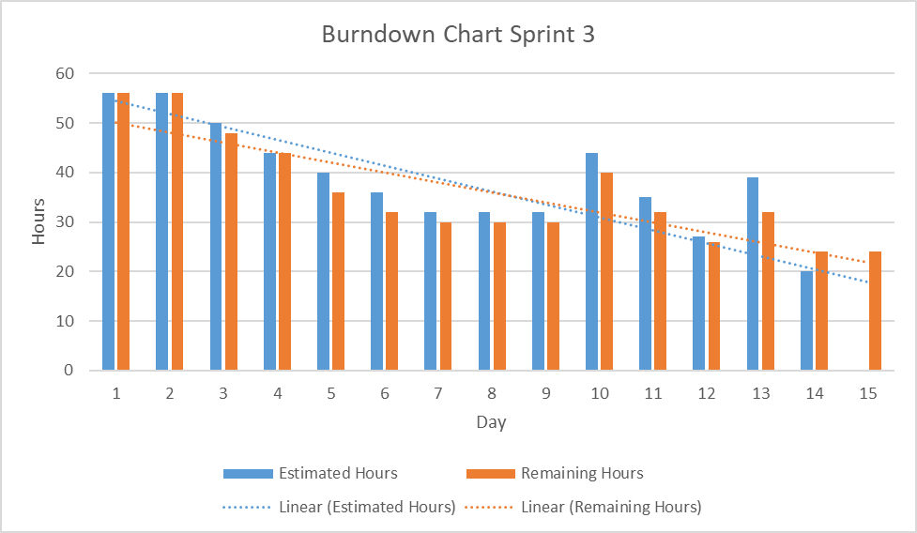

Figure 9. Burn down chart for Sprint 3 of the WalkEZ project

During this sprint, things progressed well in the first week. However, during the second week, the task of outputting certain frequencies from the DAC proved to be more challenging than the initial estimation. It turned out this would become one of the biggest challenges in this project and would require much more than the 10 hours estimated effort. With this chart, it can be seen that the discovery of the problem is around day 10 and this issue ultimately results in the group being unable to complete all the items for the sprint.

At the end of every sprint, the group meets and conducts a retrospective to assess the performance and the process of the project development. Each member discusses their own thoughts about the previous sprint and areas of improvement both individually and for the team. These retrospectives serves as a tool for reflection and is used to target the weaknesses of the group and to generate solutions to these areas.

## 3.2. Teamwork

The WalkEZ project group is consisted of only two members, Kevin and Maaz. As discussed previously, the project was managed based on a Scrum based system. Thus, during each sprint, the team would assess the items and decide who would take which task. The decision of who does what was voluntary and as such each person gravitated towards their own area of knowledge. Kevin, who was more adept at using the PIC was mainly responsible for the development of the software side of the project. Maaz, who was more proficient with hardware and circuit design was mainly responsible for the hardware components and designs. This worked well for the group overall as each member performed better in the field of their own choosing and were able to produce much better results with their specialized knowledge. However, this is not to say that sprint items were strictly separated in this way. For example, Kevin who undertook the task of interfacing the ultrasonic sensor with the PIC worked extensively with the ultrasonic sensor and Maaz who handled the 3D printing of the cane components also worked with 3D software. Furthermore, some tasks were completed with both members. An example might be the testing of the prototype which was done every sprint in which both members worked together to troubleshoot and find solutions for the product. One way the WalkEZ group kept track of what its members were doing is through the daily stand up. This was a 5 minute meeting done every working day at the start of the day. Each member would say what they worked on during the last working day, what they would work on today, and what challenges they might face. This proved to be a great tool to the WalkEZ group as it allowed for the group to be kept up to date to what each member is doing and what potential challenges they may face. Below is one document showing the written logs of the topics discussed during one of the daily stand-ups.

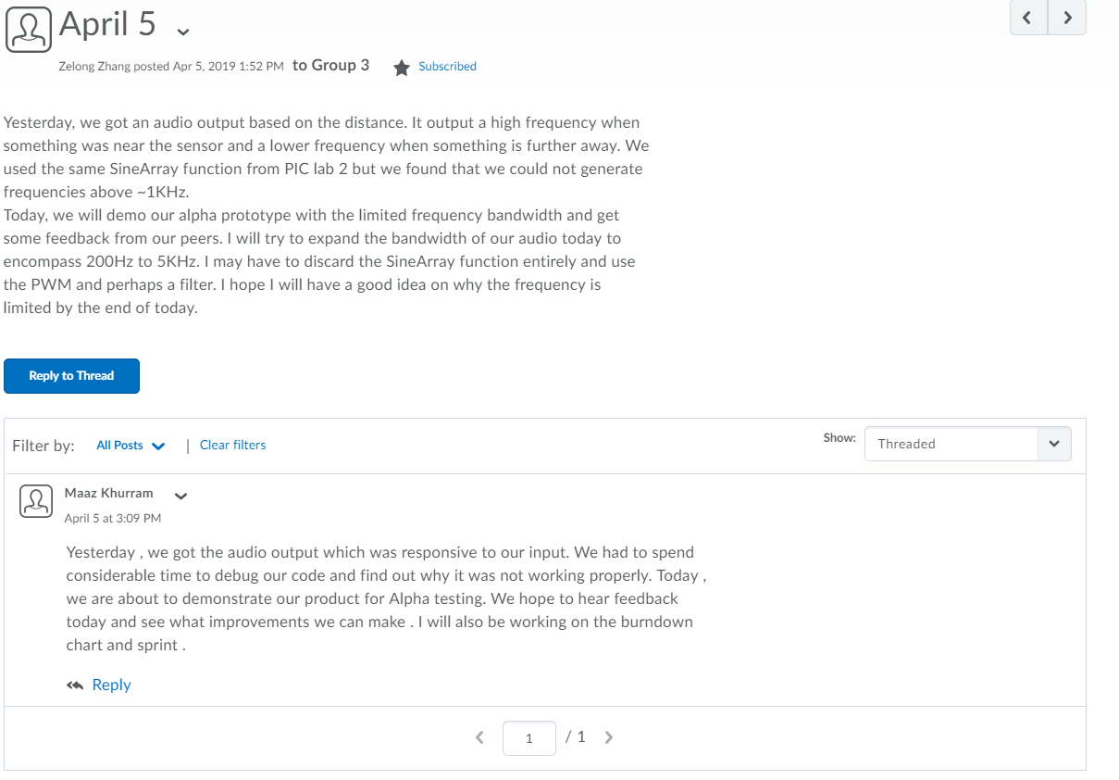

Figure 10. Daily Stand up Example Documentation

# 4. References

“Blindness in Canada.” *CNIB*, cnib.ca/en/sight-loss-info/blindness/blindness-canada?region=ab.

“Cataracts.” *National Eye Institute*, U.S. Department of Health and Human Services, nei.nih.gov/eyedata/cataract.

“HC-SR04 Ultrasonic Sensor Datasheet.” *Sparkfun*, cdn.sparkfun.com/datasheets/Sensors/Proximity/HCSR04.pdf.

Khurram, Maaz, and Kevin Zhang. “MaazKhurram/WalkEZ.” *GitHub*, github.com/MaazKhurram/WalkEZ.

“PIC16(L)F1777/8/9 Datasheet.” *Microchip*, Microchip, ww1.microchip.com/downloads/en/DeviceDoc/40001819B.pdf.

“Psychoacoustics.” *Wikipedia*, Wikimedia Foundation, 14 Mar. 2019, en.wikipedia.org/wiki/Psychoacoustics.

“TCA0372, TCA0372B, NCV0372B, 1.0 A Output Current, Dual Power Operational Amplifiers.” ON Semiconductors.

“Vision Impairment and Blindness.” *World Health Organization*, World Health Organization, www.who.int/news-room/fact-sheets/detail/blindness-and-visual-impairment.